Torriano Primary School
Torriano Avenue, London, NW5 2SJ
Tel: 0207 424 0202
E-mail: admin@torriano.camden.sch.uk

Executive Headteacher: Helen Bruckdorfer BA

Wednesday, 27 April 2022
Dear Parents and Carers,

Welcome back to the Summer Term 2022 at Torriano. For the summer term, we continue our whole school theme, The Art of Explanation. We kicked off the term by celebrating Earth Day on Friday, encouraging the children to consider innovative ways to help combat climate change and develop our relationship with nature. We will also be taking part in a whole school project called The World Reimagined.

Reception and Nursery will also embark on their STEAM learning and project. They will use their science learning to further develop their investigative skills with our Scientist in Residence Dr Lucy Collinson from the CRICK Institute. We will also be celebrating the Queen’s Platinum Jubilee at the end of this half term.

This letter and curriculum leaflet gives further information regarding this term’s learning. You will be updated regularly through the newsletter, website and school Twitter feed @TorrianoJuniorS .
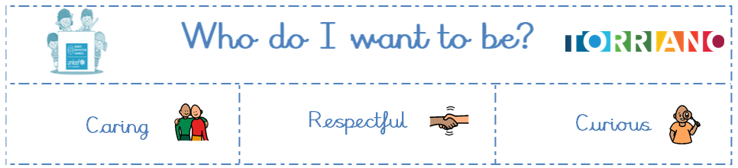

Learning in Nursery
The attached curriculum leaflet gives you an overview of the learning that will be taking place this term in Nursery. Through our STEAM project the children will be learning about materials and changing states of matter. In summer 2, our focus will be around planting and growing.
Trips
We are delighted to be able to plan and take children on a range of educational trips once again. All trips will be risk assessed and you will be informed about them in advance. This term we are planning a trip to a local shop and a café.

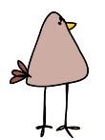
Attendance and Punctuality

Ted and Earl will be on the lookout for good attendance and prompt school arrival this term. We will be celebrating good attendance and time-keeping behaviour in class. Attendance at school is essential for all children, to support their academic development and wellbeing. We continue to work towards our attendance target of 97%. We appreciate the challenges that Covid presents and take this into account for children’s attendance. We encourage you to monitor your child’s attendance using Arbor to ensure their attendance remains excellent. Please ensure you download the Arbor App to access your child’s profile and complete payments.

Home Learning

Phonics - Little Wandle  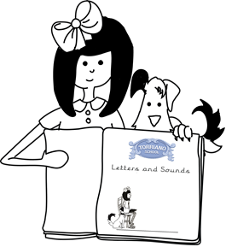 | The spring term saw the successful implementation of the new systematic synthetic phonics programme ‘Little Wandle’ across Reception and Key Stage 1 and foundations for phonics is an integral part of our Nursery provision. Children follow the Little Wandle Letters and Sounds Revised ‘Foundations for Phonics’ guidance. The focus is on daily oral blending and language development through high quality stories and rhymes.
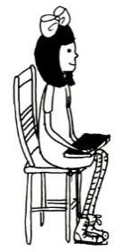  Home reading | Parental support is hugely important for developing reading skills, confidence and understanding. Even if children are independent readers, we still encourage parents to read with them or listen to them and discuss the books they are reading.  Reading daily at home with an adult is crucial to helping your child make progress. In Nursery, children should be reading at home for around 10 minutes a day. To help the teachers understand what and how much children are reading, we request that parents/carers complete their reading record (‘Monkey Book’) once a week with a simple comment. Reading records and books must be brought in to class every day (in your child’s school book bag). Reading records will be checked regularly by adults, with a teacher comment once a week.
Maths | Developing a strong grounding in number is essential to enable your child to feel confident in maths. Revising number facts, including counting and recognising numbers, is an easy way to support your child’s progress in mathematics and we encourage children to revise them regularly. It is important to support children to solve problems using fingers, objects and marks: “There are three of you, but there aren’t enough chairs….” When counting objects, ask your child to count them and then repeat the last number. For example: “1, 2, 3 – 3 cars”, helping them understand that the last number reached when counting a small set of objects tells you how many there are in total (‘cardinal principle’).
New words  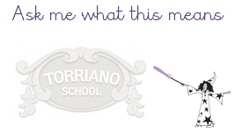  oracy | Direct vocabulary teaching takes place each week. On a Friday, children choose one of their new words to wear on a sticker. We encourage you to speak to your child about their chosen word each week as this will help them to deepen their understanding of the word and to develop their oracy skills!
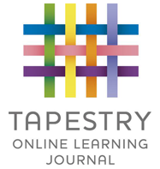  Tapestry | In EYFS, we use an online learning journal called ‘Tapestry’. Staff use this to share examples of your child’s learning through photos and videos of what they have been doing in school. You can download the ‘Tapestry’ application onto your tablet or phone to view these and can also use the app to share news and learning which has taken place at home. If you need any assistance with accessing Tapestry, please speak to one of the Reception Team.

Poem book, reading books and reading records should be kept in a book bag as these are used/referred to regularly in class.

PE

PE will take place every Tuesday. Children will not be changing for PE so please ensure they wear appropriate clothes for physical activity on these days, including trainers. Please note, we have and will continue to do a Daily Mile, so it is important that children wear appropriate footwear daily.

We look forward to an exciting year and are available at pickup to discuss any queries at the end of each school day.

Kind regards,

Stana Downie and Huda Warsame
Nursery Teachers

